**Question**

Implement classification on the Iris Dataset using Multi Layer Perceptron and compare with the other models.

**Source Code**

import tensorflow as tf

from tensorflow import keras

from sklearn.datasets import load_iris

from sklearn.model_selection import train_test_split

from sklearn.preprocessing import OneHotEncoder

from sklearn.metrics import accuracy_score, precision_score, recall_score, f1_score

from matplotlib import pyplot as plt

iris = load_iris()

X = iris.data

y = iris.target.reshape(-1, 1)

encoder = OneHotEncoder(sparse_output=False)

y = encoder.fit_transform(y)

X_train, X_test, y_train, y_test = train_test_split(X, y, test_size=0.2, random_state=42)

def build_model(hidden_units=10):

model = keras.Sequential()

model.add(keras.layers.Dense(hidden_units, input_shape=(4,), activation='relu'))

model.add(keras.layers.Dense(hidden_units, activation='relu'))

model.add(keras.layers.Dense(3, activation='softmax'))

model.compile(optimizer='adam', loss='categorical_crossentropy', metrics=['accuracy'])

return model

def train_model(model, epochs=100, batch_size=8, validation_split=0.2):

early_stopping = keras.callbacks.EarlyStopping(

monitor='val_loss',

patience=10,

restore_best_weights=True

)

reduce_lr = keras.callbacks.ReduceLROnPlateau(

monitor='val_loss',

factor=0.1,

patience=5

)

best_model = keras.callbacks.ModelCheckpoint(

'model.keras',

save_best_only=True

)

hist = model.fit(

X_train, y_train,

epochs=epochs,

batch_size=batch_size,

validation_split=validation_split,

callbacks=[early_stopping, reduce_lr, best_model]

)

return hist

def evaluate(hist, model, X_test, y_test, model_name='Multi Layer Perceptron'):

y_pred = model.predict(X_test)

y_pred_classes = tf.argmax(y_pred, axis=1)

y_test_classes = tf.argmax(y_test, axis=1)

accuracy = accuracy_score(y_test_classes, y_pred_classes)

precision = precision_score(y_test_classes, y_pred_classes, average='weighted')

recall = recall_score(y_test_classes, y_pred_classes, average='weighted')

f1 = f1_score(y_test_classes, y_pred_classes, average='weighted')

print(f'Model: {model_name}')

print(f'Accuracy: {accuracy:.4f}')

print(f'Precision: {precision:.4f}')

print(f'Recall: {recall:.4f}')

print(f'F1 Score: {f1:.4f}')

print()

plt.plot(hist.history['accuracy'], label='Train Accuracy')

plt.plot(hist.history['val_accuracy'], label='Validation Accuracy')

plt.title('Model Accuracy')

plt.ylabel('Accuracy')

plt.xlabel('Epoch')

plt.legend(loc='best')

plt.show()

plt.plot(hist.history['loss'], label='Train Loss')

plt.plot(hist.history['val_loss'], label='Validation Loss')

plt.title('Model Loss')

plt.ylabel('Loss')

plt.xlabel('Epoch')

plt.legend(loc='best')

plt.show()

def main():

model = build_model(hidden_units=10)

hist = train_model(model, epochs=100, batch_size=8, validation_split=0.2)

evaluate(hist, model, X_test, y_test, model_name='MLP with Early Stopping')

if __name__ == '__main__':

main()

**Output**

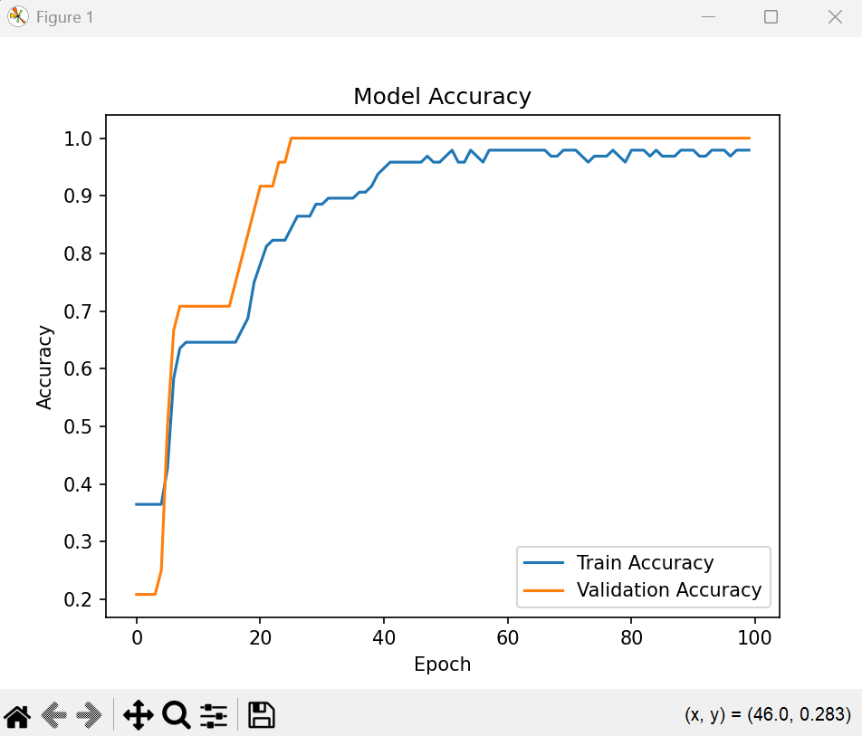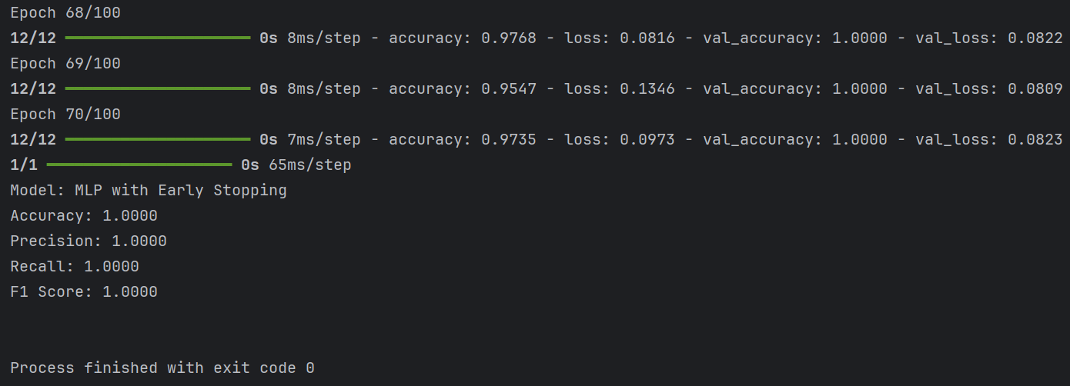*Terminal*

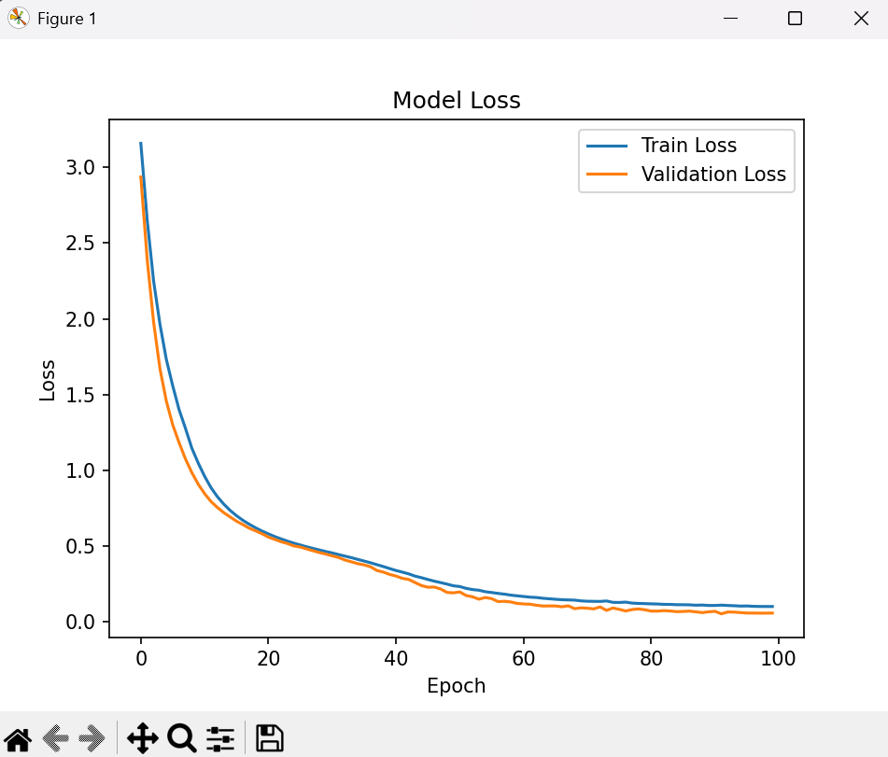Plot training and validation accuracy *Plot training and validation loss*

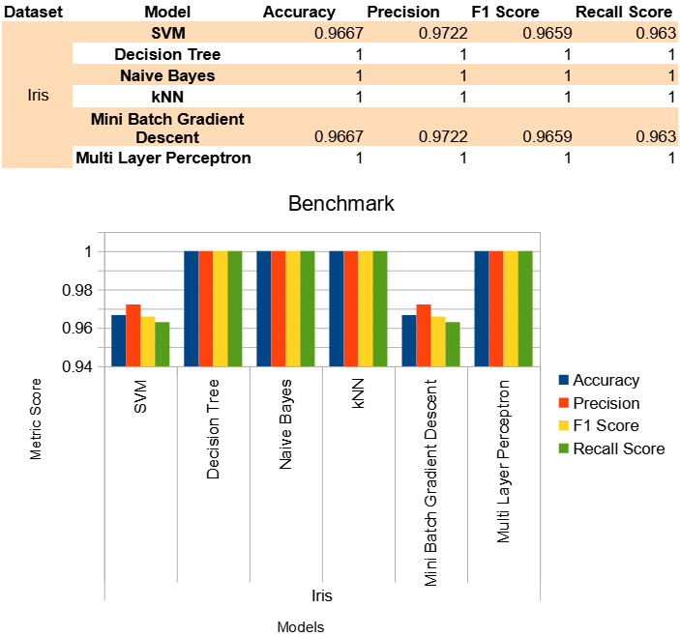**Comparison**